Tiana Le

Homework 3

September 29th, 2023

I installed automatic 1111 stable diffusion. I never experimented with the sampling methods until now. I didn’t expect the image to change completely when changing the sampling method, even though I kept the same seed. Some sampling methods produce similar or identical results such as PLMS, DPM++ 2M, LMS Karras, and DPM2 Karras.

I experimented with different CFG scales too and actually referred to the model I used called [absolute reality](https://civitai.com/models/81458/absolutereality). The details for that model said to use cfg 4.5-10 but I actually liked the result I got from a cfg scale of 3. I put the cfg scale at the highest (30) and the image came out bad, the shapes weren’t well defined and it didn’t have much detail.

I started with the default sampling steps at 20 and then tried the maximum. The maximum sampling steps came out nice so I kept my sampling step at 150.

Something that I learned from your last lecture is to always check the notes from any model I use. I didn’t realize each model had a set cfg scale to use. That explains why in the past, I got bad results and I couldn’t figure out why. Another thing I will plan to do when working on an image generation project is experiment more with the sampling method.

Prompt: bubble gum and candy inside of a claw machine from the 1950s, americana, america, retro, inside an arcade with arcade games in the background <lora:badvhs_v1:1>

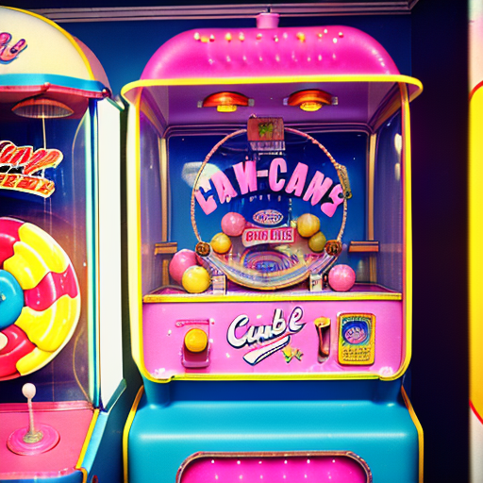

512 x 512

Sampling steps: 20

Seed: 5142

Cfg scale: 10

Sampling method: euler a



Cfg scale: 18

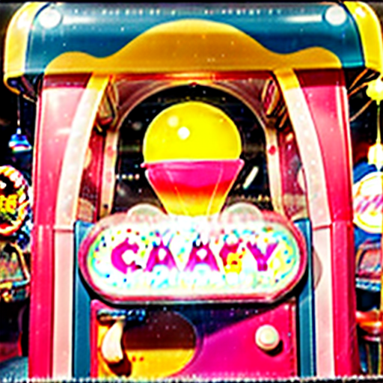

Cfg scale: 30

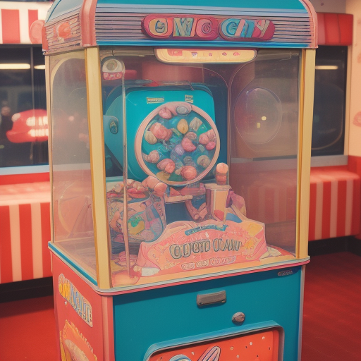

Cfg scale: 3

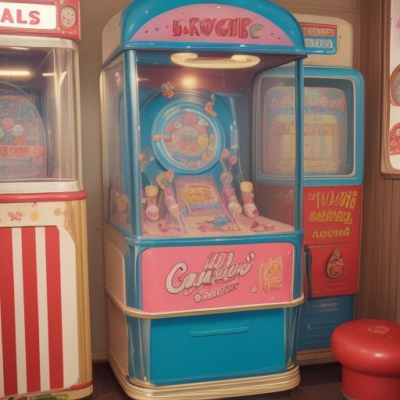

Cfg scale: 2.5

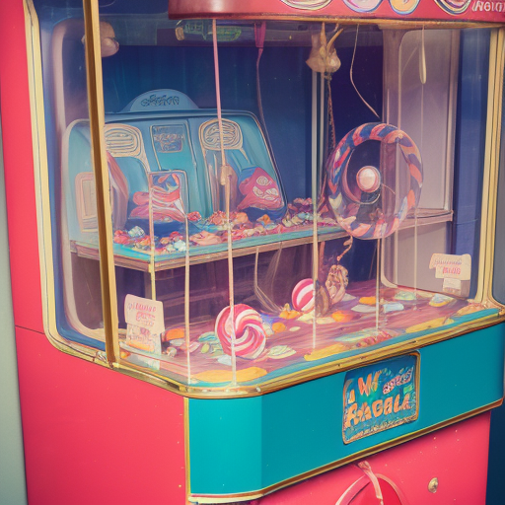

Cfg scale: 3

Sampling steps: 130

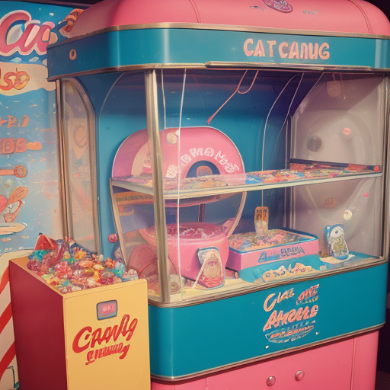

Cfg scale: 3

Sampling steps: 150

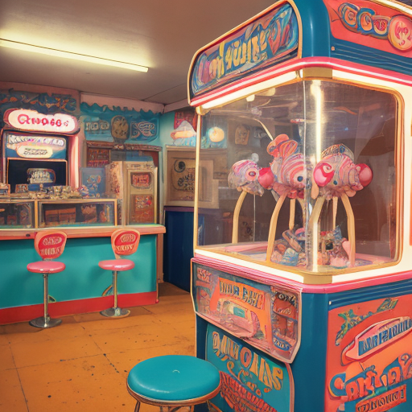

Cfg scale: 3

Sampling steps: 150

Sampling method: PLMS

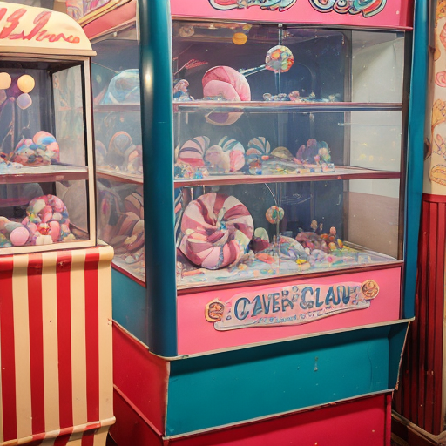

Cfg scale: 3

Sampling steps: 150

Sampling method: DPM fast

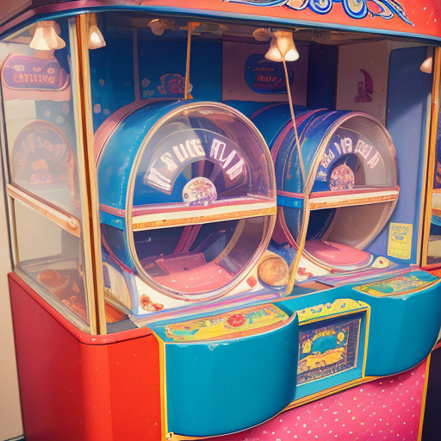

Cfg scale: 3

Sampling steps: 150

Sampling method: DPM++ 2s a

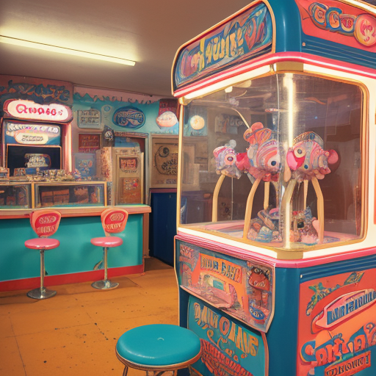

Cfg scale: 3

Sampling steps: 150

Sampling method: DPM++ 2M



Cfg scale: 3

Sampling steps: 150

Sampling method: DPM++SDE



Cfg scale: 3

Sampling steps: 150

Sampling method: DPM++2M SDE

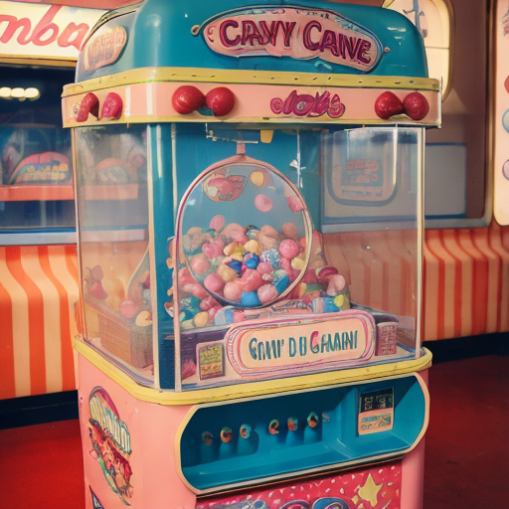

Cfg scale: 3

Sampling steps: 150

Sampling method: DPM adaptive

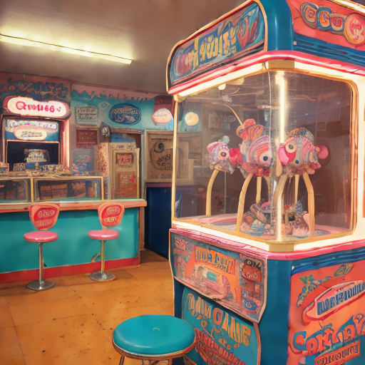

Cfg scale: 3

Sampling steps: 150

Sampling method: LMS Karras

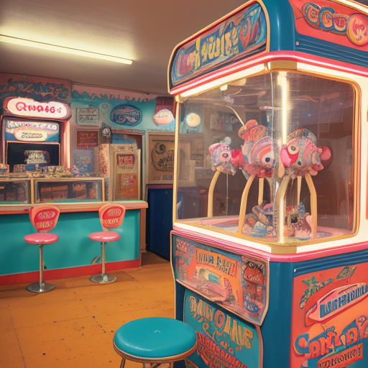

Cfg scale: 3

Sampling steps: 150

Sampling method: DPM2 Karras

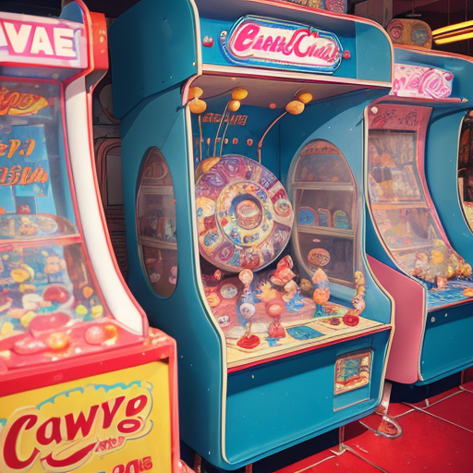

Cfg scale: 3

Sampling steps: 150

Sampling method: DPM2 a karras

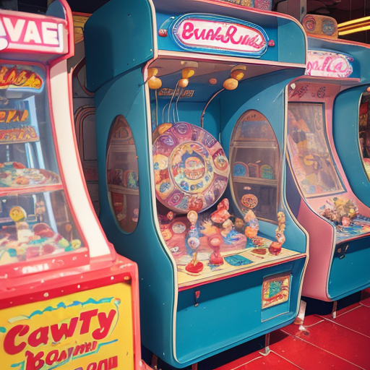

Cfg scale: 3

Sampling steps: 150

Sampling method: DPM++2s a karras